How to use Visual Studio Code for Java Development
Windows Guide Version 2.0

By Seth G. R. Herendeen

Step One: Acquire Visual Studio Code
- To get Visual Studio Code, simply navigate to https://code.visualstudio.com/ and download the program. Install. You do not need to worry about payment because the program is free & open-sourced.
- If you already have Visual Studio Code, proceed to the next step.
Step Two: Acquire Java JDK
- Acquire the jdk at http://www.oracle.com/technetwork/java/javase/downloads/index.html. You needn’t download the x86 version unless you are running on a crappy x86 (you probably are not!).
- If you already have the JDK, proceed to the next step.
Step Three: Get the Java Support Extensions
- To save time, we can opt to install the Java Extension Pack by Microsoft, which is a bundle of numerous java extension packs for Visual Studio Code. This includes, but is not limited to, debugging functionality, intellisense for java and launch options.
Step Four: Fixing the Path
- Unfortunately, many people encounter an issue with Visual Studio Code in regards to java: it can’t seem to find JAVA_HOME. You will find out quickly if you have this problem because debugging/running from VSCODE will not work and it will notify you.
- Fret not: this is easily fixed.
- Locate your JDK in your \Program Files\ directory on your C:\. For me it was in C:\Program Files\Java\jdk1.8.0_152
- Copy the install path to your JDK and go to Visual Studio Code.
- Go to File > Preferences > Settings
- Then go to Workplace Settings
- In the search box, type “java.home”
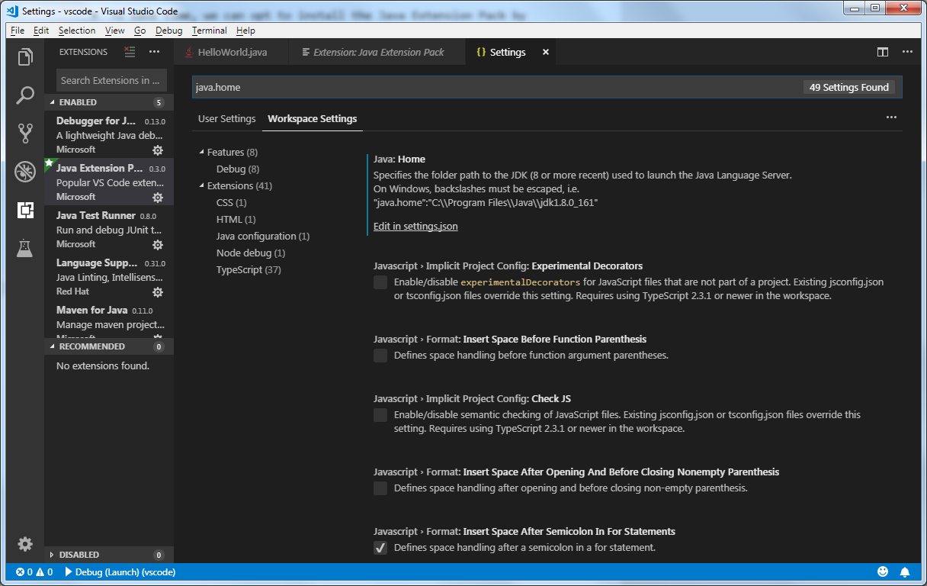
- Click on the hyperlink where it says “Edit in settings.json”
- Paste the path to your Java Home in the place represented in the subsequent picture.
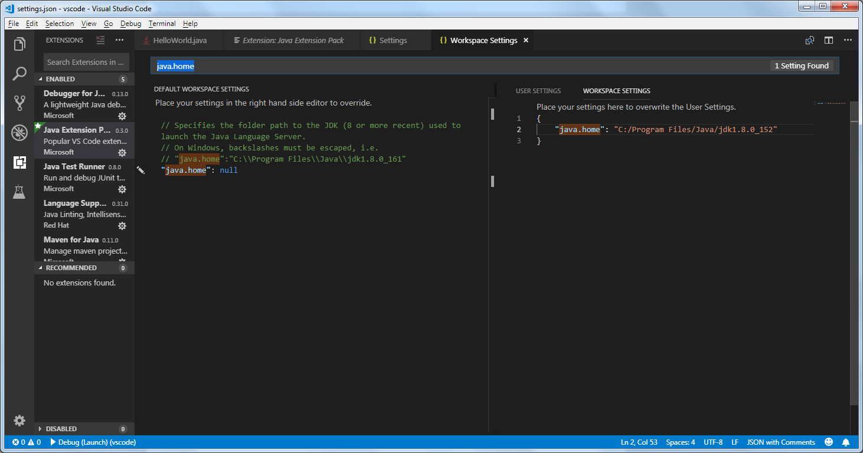
- Save changes and restart Visual Studio Code.
- If you run a program, it should by default show the output in the integrated debug console. This is great but usually does not allow you to input information. To fix this, edit your launch.json file.
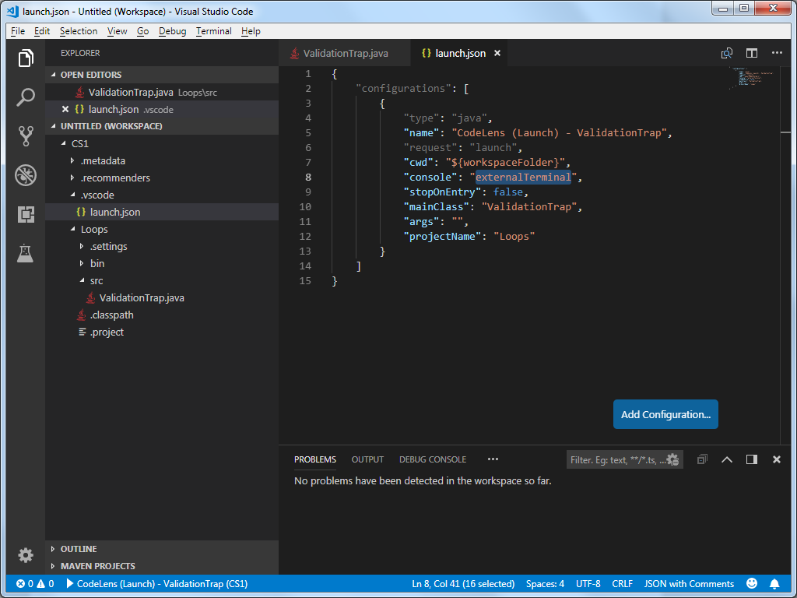
- Set the field for “console” from integrated console to “externalConsole” like how the picture has it formatted.
- Your result should look like the following picture when running/debugging programs in the future.
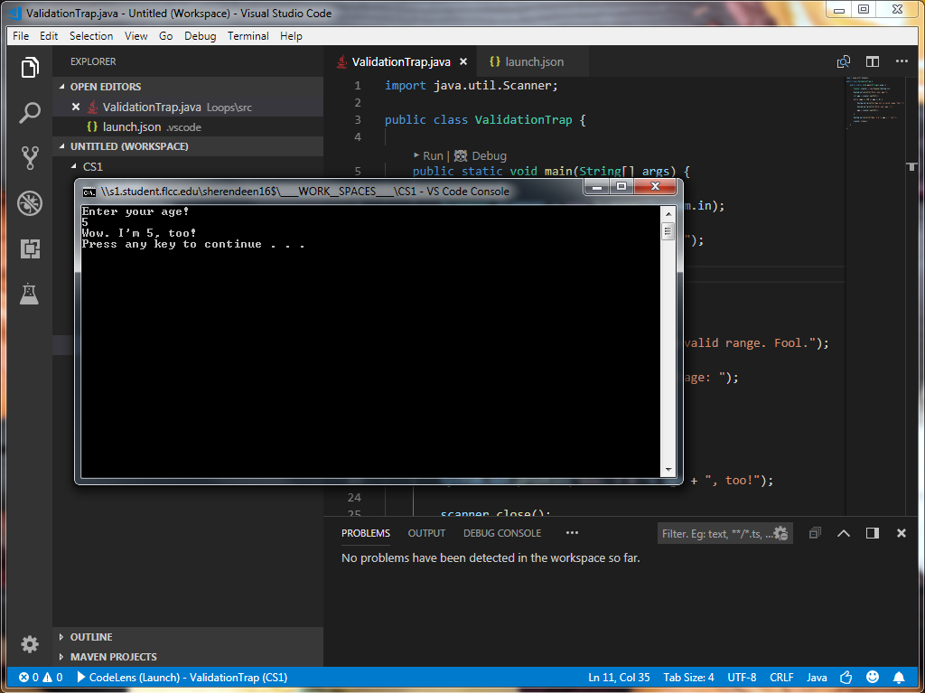
- That should be it!

Additional Information:
Java support in VSCODE seems to be optimized mostly for either Springboot or Maven projects.

